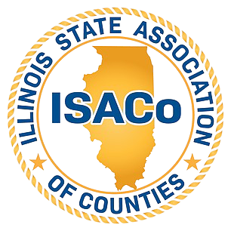

Social Media Advocacy Messages

Here are 7 advocacy messages you can post to your social media feeds to support HB 3563/SB 2416:

Message 1
On behalf of [County Name], we urge support for HB 3563/SB 2416 – the Wind and Solar Facility Resident Protection Act.
This bill gives counties the tools to protect farmland, residents & the environment.
#ProtectILCounties #LocalControl #ILGA

Message 2
Why support HB 3563/SB 2416?
✅ Counties can approve drainage plans
✅ Independent consultants (not developers)
✅ Financial guarantees for deconstruction
We need transparency & protection for our communities.
#HB3563 #SolarWindResponsibility

Message 3
Wind & solar are welcome—but not at the expense of clean water.
HB 3563/SB 2416 requires NPDES permits for large projects & affirms counties’ right to enforce stormwater rules.
Let’s build green the right way. 🌱💧
#ILGA #CleanEnergyResponsibly

Message 4
HB 3563/SB 2416 protects neighborhoods by:
🏡 Keeping industrial wind/solar out of residential areas
🌾 Allowing only in ag/manufacturing zones
📊 Applying LaSalle zoning standards
Support thoughtful, balanced land use.
#ProtectCommunities #ILCounties

Message 5
Solar farms don’t have to be eyesores.
HB 3563/SB 2416 lets counties require berms & screening to:
🌳 Improve aesthetics
🔇 Reduce noise
💧 Control runoff
Let’s make renewable energy work for everyone.
#SolarWithSense #SmartSiting #ILLegislation

Message 6
Supporting HB 3563/SB 2416 = protecting what matters most:
🏡 County residents
🌾 Productive farmland
🌎 The environment
💰 Property values

This bill ensures wind & solar projects are safe, smart, and community-focused.
#HB3563 #ProtectILCounties #SmartGrowth

Message 7
Counties support the sensible changes to wind and solar facility law within HB 3563/SB 2416. Click here to learn more about the legislation.

